EAGLEGATE Plugin: v1 Documentation
Sep 29, 2026 · @Co

What EAGLEGATE is
EAGLEGATE is a plugin for OpenC3 COSMOS, a ground system for talking to spacecraft and hardware. It adds a firewall: every telemetry packet arriving from the device over TCP is checked, and only packets allowed by a set of rules reach the rest of COSMOS. The rules live in a JSON file that operators can change on a running system, without reinstalling anything.
You mostly need Python to work on it. COSMOS itself runs in Docker containers; our code is a small piece that COSMOS loads and calls.
Terms you will see everywhere
Term | Meaning
Plugin | A package COSMOS installs. Ours is built into a .gem file (a Ruby package format, used even for Python plugins)
Target | Something COSMOS talks to, here the EAGLEGATE device. A target folder holds packet definitions, screens, scripts and code
Interface | The connection to the device (for us, a TCP socket). COSMOS runs each interface as its own background process
Protocol | Code attached to an interface that processes raw bytes. Our firewall is a protocol
Packet | One unit of data. Telemetry = data from the device; a command = data sent to it
CCSDS | A standard packet format used by spacecraft. Every packet starts with a 6-byte header
APID | A number (0 to 2047) in the CCSDS header saying which kind of packet it is. The firewall rules mostly filter on APID
Microservice | Any COSMOS background process. You rarely touch these directly
Valkey | The database COSMOS services use to pass data to each other. Our code never talks to it directly

The important files
Four files hold almost all the logic: plugin.txt, the two Python files in lib/, and firewall_rules.json. Everything else is configuration, display, or tests.
File | What it does | Edit it when
plugin.txt | Tells COSMOS what to create: the EAGLEGATE target, the TCP interface (host, port), and the firewall protocol with its settings | Changing connection settings or the hard size limit
plugin.gemspec, Rakefile | Instructions for building the .gem file | Rarely
targets/EAGLEGATE/target.txt | Target settings; must contain LANGUAGE PYTHON | Rarely
targets/EAGLEGATE/cmd_tlm/tlm.txt | Describes each telemetry packet byte by byte, and which APID identifies it | Adding or changing a telemetry packet
targets/EAGLEGATE/cmd_tlm/cmd.txt | Same, for commands sent to the device | Adding or changing a command
targets/EAGLEGATE/lib/eaglegate_firewall_protocol.py | The firewall itself. Cuts the byte stream into packets, applies the safety checks and the rules, reloads rules on request | Changing how filtering works
targets/EAGLEGATE/lib/eaglegate_rules.py | The rules engine: reads the JSON rules, checks them for mistakes, decides ALLOW or DENY per packet. No COSMOS code inside, so it is the easiest file to start with | Adding a new kind of rule condition
targets/EAGLEGATE/rules/firewall_rules.json | The rules themselves. The format is described at the top of eaglegate_rules.py | Changing what is allowed (usually on the live system, see below)
targets/EAGLEGATE/procedures/apply_firewall_rules.py | Script operators run in COSMOS to apply edited rules safely | Rarely
targets/EAGLEGATE/screens/status.txt | The telemetry display page shown in COSMOS | Changing what operators see
tests/ | Automated tests, run on your own computer without COSMOS | Whenever you change code or rules
requirements-dev.txt | Python packages the tests need | When COSMOS is upgraded
There are two layers of protection, and it helps to keep them apart. The safety checks (valid CCSDS header, packet not larger than the limit in plugin.txt) are hardcoded and always run first. The rules in the JSON file run after that, and a bad rules file can never switch the safety checks off.

How the code runs (call stacks)
Our code never runs on its own: COSMOS calls it, once per chunk of bytes from the device and once per rules reload.
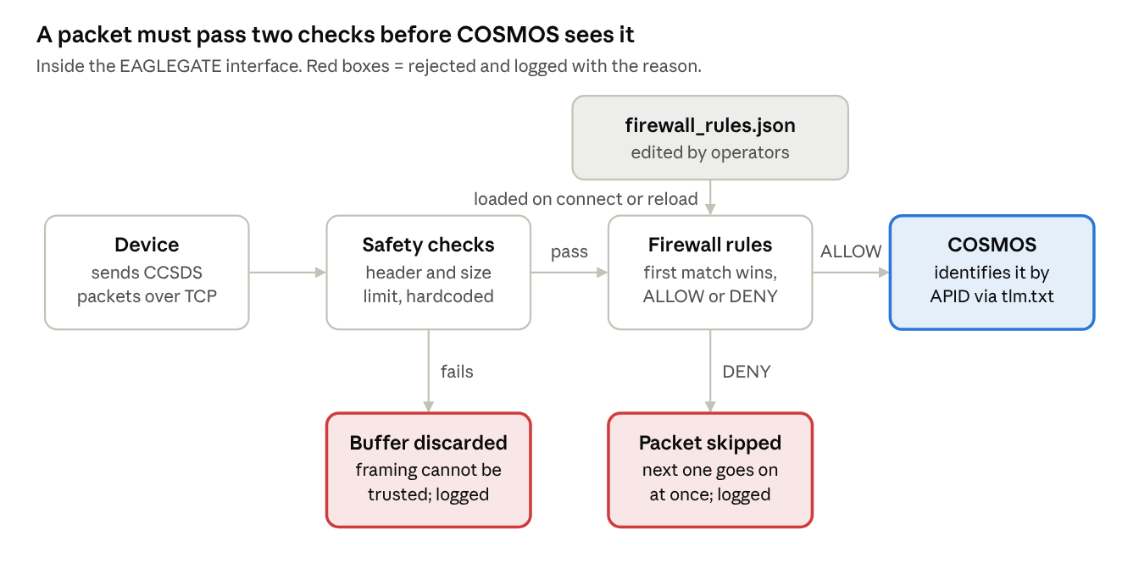
telemetry path through the firewall · 2 checks, 2 ways to be rejected
The safety checks run on the 6-byte header before the rest of the packet is even read, so a packet claiming to be huge is rejected immediately.
A telemetry packet arriving, function by function (indentation = "calls"; ours in eaglegate_firewall_protocol.py unless noted):
Interface.read() COSMOS: reads bytes from TCP
EaglegateFirewallProtocol.read_data() ours: loop, one packet at a time
LengthProtocol.read_data() COSMOS: collects bytes
reduce_to_single_packet() ours: safety checks on the header
ruleset.evaluate(packet) eaglegate_rules.py: ALLOW or DENY
DENY -> _reject() logs it, loop takes the next packet
ALLOW -> packet returned to COSMOS
COSMOS identifies the packet using tlm.txt, then stores and displays it
A rules reload, from the operator's click to the new rules being active:
apply_firewall_rules.py operator runs it in Script Runner
compile_ruleset(text) eaglegate_rules.py: stop here if invalid
interface_protocol_cmd("EAGLEGATE_INT", "RELOAD_RULES")
... COSMOS delivers it to the running interface ...
EaglegateFirewallProtocol.protocol_cmd() ours
load_rules() ours: read file, compile, swap
interface_details() script confirms the new version
The same load_rules() also runs every time the interface connects, through connect_reset().

How to launch it
Launching means three things: COSMOS running, the plugin built into a .gem file, and that file installed into COSMOS. You need Docker and a COSMOS installation (a clone of the cosmos-project repository, set up per the installation guide).
- Start COSMOS. In the cosmos-project folder run ./openc3.sh run, wait a minute, then open http://localhost:2900 in a browser. The first visit asks you to set a password.
- Build the plugin. In the openc3-cosmos-eaglegate folder run:
openc3.sh cli rake build VERSION=1.0.0
This creates openc3-cosmos-eaglegate-1.0.0.gem. If it fails with pnpm run build failed, a leftover package.json from an old web-tool experiment is in the folder; move it out.
- Install it. In COSMOS open the Admin Console, go to the Plugins tab, and install the .gem file. COSMOS then shows the plugin's settings: target name, host, port and fw_max_length. The defaults suit a device running on your own computer.
- Check it is working.
  - In CmdTlmServer, the Interfaces tab should show EAGLEGATE_INT. It only says CONNECTED while the device (or a simulator) is listening on the configured host and port; otherwise it keeps retrying, which is normal.
  - Firewall messages (rules loaded, packets rejected) appear in the COSMOS log messages, prefixed with EAGLEGATE_INT firewall.
  - Telemetry Viewer shows the EAGLEGATE status screen.
- Upgrade after a change. Build again with a higher version (VERSION=1.0.1), then upgrade the existing plugin in the Admin Console with the new file. Upgrading keeps any rules edited on the live system; uninstalling and reinstalling can lose them.
host.docker.internal means "the computer COSMOS is running on". It works as-is on Mac and Windows; on Linux it needs an extra line in COSMOS's compose.yaml.

How to change the firewall rules
Rules change in two steps: edit the JSON file, then run the apply script. Nothing needs rebuilding or reinstalling.
- Edit EAGLEGATE/rules/firewall_rules.json through COSMOS (for example in Script Runner) and increase its version number.
- Run EAGLEGATE/procedures/apply_firewall_rules.py in Script Runner. It checks the file for mistakes first and changes nothing if it finds one. Otherwise it tells the interface to reload and confirms the new version is active.
A rule is a condition plus a decision. Rules are checked top to bottom and the first match wins; if none match, default_action decides.
{
"version": 2,
"default_action": "DENY",
"rules": [
{ "id": "deny-commands-on-tlm-link", "action": "DENY", "match": { "packet_type": "CMD" } },
{ "id": "allow-housekeeping", "action": "ALLOW", "match": { "apid": ["0x002", "0x003"] } }
]
}
What keeps this safe:
- A misspelled key (say apids instead of apid) is an error, not ignored. Ignoring it would turn a narrow rule into one that matches every packet.
- A broken file never replaces working rules; the previous rules stay active. If no valid rules were ever loaded, everything is denied.
- Reloading requires the COSMOS system_set permission.
To see what is running, call interface_details("EAGLEGATE_INT") in Script Runner and look at read_protocols[0]["firewall"]: the active version, how many packets each rule has matched, and any load error.

How to test it
The 50 automated tests run on your own computer in about a second, with no Docker and no COSMOS running. They use the real COSMOS framework code (from the openc3 Python package) with a fake TCP connection feeding in packets.
One-time setup (Python 3.11 or newer), from the openc3-cosmos-eaglegate folder:
python3 -m venv .venv
source .venv/bin/activate
pip install -r requirements-dev.txt
On Windows, activate with .venv\Scripts\activate instead. Make sure the openc3== version in requirements-dev.txt matches our COSMOS version.
Every time: activate the environment (source .venv/bin/activate), then run pytest. A good run ends with 50 passed.
Command | Runs
pytest | Everything
pytest -v | Everything, listing each test by name
pytest tests/test_rules_engine.py | One file
pytest -k reload | Tests with "reload" in their name

Test file | What it checks
test_rules_engine.py | Rule matching, and that every kind of mistake in a rules file is caught with a clear message. Also checks the shipped firewall_rules.json is valid
test_firewall_protocol.py | The firewall inside a real COSMOS interface: packets allowed and denied, hostile packets, reloading rules mid-stream, random garbage input
test_apply_procedure.py | The operator script, end to end, with COSMOS's script functions faked
conftest.py | Shared helpers, not tests. ccsds() builds a test packet
When a test fails, pytest prints the test's name and the exact line that did not hold, with the actual and expected values. Read the test first: each one is short and says in its name what it expects. Run pytest before every commit and after editing firewall_rules.json.
On the live system, install the plugin, send a packet with an APID the rules deny, and check that a rejection appears in the log and nothing arrives in Packet Viewer.

Open items and further reading
The firewall code and tests are done; the packet definitions are not. Good first tasks, roughly in order:
- ☐ Replace the generator-default tlm.txt with CCSDS packets: a 6-byte header, identified by APID, one packet per allowed APID. Until then, packets that pass the firewall arrive as UNKNOWN
- ☐ Same for cmd.txt, if the device expects CCSDS commands
- ☐ Update screens/status.txt to the new packet and item names
- ☐ Delete lib/old_eaglegate.py and procedures/old_procedure.py
- ☐ Write a small device simulator (a Python TCP server sending CCSDS packets) so the interface can connect during development
- ☐ On first install, confirm the interface log shows the rules loading, and that the apply script runs in Script Runner. The tests cover everything else, but these two only a live COSMOS can confirm
- ☐ Limit how often rejections are logged, so a noisy device can't flood the log
Further reading, in this order: Plugins, Targets, Telemetry, Protocols, and Code Generators.

